**Mcdonald’s Market Target Segmentation using K-means**

* **Team madhur**
* Madhur Sharma
* Naveen Kumar
* Anduri Roshan
* Animisha Gadde

**Step 1: Deciding (not) to Segment**

**Implications of Committing to Market Segmentation**

The key implication is that the organisation needs to commit to the segmentation strategy on the long term. Market segmentation is a marriage, not a date. The commitment to market segmentation goes hand in hand with the willingness and ability of the organisation to make substantial changes.

**Implementation Barriers**

* The first group of barriers relates to senior management. Lack of leadership, pro-active championing, commitment and involvement in the market segmentation process by senior leadership undermines the success of market segmentation.
* A second group of barriers relates to organisational culture. Lack of market or consumer orientation, resistance to change and new ideas, lack of creative thinking, bad communication and lack of sharing of information and insights across organisational units, short-term thinking, unwillingness to make changes and office politics have been identified as preventing the successful implementation of market segmentation.
* Another potential problem is lack of training. If senior management and the team tasked with segmentation do not understand the very foundations of market segmentation, or if they are unaware of the consequences of pursuing such a strategy, the attempt of introducing market segmentation is likely to fail.
* Another obstacle may be objective restrictions faced by the organisation, including lack of financial resources, or the inability to make the structural changes required.

Most of these barriers can be identified from the outset of a market segmentation study, and then proactively removed. If barriers cannot be removed, the option of abandoning the attempt of exploring market segmentation as a potential future strategy should be seriously considered.

**Step 2: Specifying the Ideal Target Segment**

**Segment Evaluation Criteria**

In Step 2 the organisation must determine two sets of segment evaluation criteria.

**Knock-out criteria**: These criteria are the essential, non-negotiable features of segments that the organisation would consider targeting.

**Attractiveness criteria:** These criteria are used to evaluate the relative attractiveness of the remaining market segments – those in compliance with the knock-out criteria.

**Knock-Out Criteria**

Knock-out criteria are used to determine if market segments resulting from the market segmentation analysis qualify to be assessed using segment attractiveness criteria. The first set of such criteria was suggested by Kotler (1994) and includes substantiality, measurability and accessibility (Tynan and Drayton 1987).

* The segment must be homogeneous; members of the segment must be similar to one another.
* The segment must be distinct; members of the segment must be distinctly different from members of other segments.
* The segment must be large enough; the segment must contain enough consumers to make it worthwhile to spend extra money on customising the marketing mix for them.
* The segment must be matching the strengths of the organisation; the organisation must have the capability to satisfy segment members’ needs.
* Members of the segment must be identifiable; it must be possible to spot them in the marketplace.
* The segment must be reachable; there has to be a way to get in touch with members of the segment in order to make the customised marketing mix accessible to them.

**Attractiveness Criteria**

In addition to the knock-out criteria, there is a wide range of segment attractiveness criteria available to the segmentation team to consider when deciding which attractiveness criteria are most useful to their specific situation.

**Step 3: Collecting Data**

Empirical data forms the basis of both common sense and data-driven market segmentation. Empirical data is used to identify or create market segments and later in the process – describe these segments in detail.

Throughout this book we use the term segmentation variable to refer to the variable in the empirical data used in common sense segmentation to split the sample into market segments. In common sense segmentation, the segmentation variable is typically one single characteristic of the consumers in the sample. Each row in this table represents one consumer, each variable represents one characteristic of that consumer. An entry of 1 in the data set indicates that the consumer has that characteristic. An entry of 0 indicates that the consumer does not have that characteristic. The common sense segmentation uses gender as the segmentation variable. Market segments are created by simply splitting the sample using this segmentation variable into a segment of women and a segment of men. All the other personal characteristics available in the data – in this case: age, the number of vacations taken, and information about five benefits people seek or do not seek when they go on vacation – serve as so-called descriptor variables. They are used to describe the segments in detail. Describing segments is critical to being able to develop an effective marketing mix targeting the segment. Typical descriptor variables include sociodemographics, but also information about media behaviour, allowing marketers to reach their target segment with communication messages.

**Data from survey studies**

Most market segmentation analyses are based on survey data. Survey data is cheap and easy to collect, making it a feasible approach for any organisation. But survey data – as opposed to data obtained from observing actual behaviour – can be contaminated by a wide range of biases. Such biases can, in turn, negatively affect the quality of solutions derived from market segmentation analysis.

**Data from Internal Sources**

Increasingly organisations have access to substantial amounts of internal data that can be harvested for the purpose of market segmentation analysis. Typical examples are scanner data available to grocery stores, booking data available through airline loyalty programs, and online purchase data.

**Data from Experimental Studies**

Another possible source of data that can form the basis of market segmentation analysis is experimental data. Experimental data can result from field or laboratory experiments. For example, they can be the result of tests how people respond to certain advertisements. The response to the advertisement could then be used as a segmentation criterion. Experimental data can also result from choice experiments or conjoint analyses. The aim of such studies is to present consumers with carefully developed stimuli consisting of specific levels of specific product attributes. Consumers then indicate which of the products – characterised by different combinations of attribute levels – they prefer. Conjoint studies and choice experiments result in information about the extent to which each attribute and attribute level affects choice. This information can also be used as a segmentation criterion

**Step 5: Extracting Segments**

**Grouping Consumers:**

Data-driven market segmentation analysis is exploratory by nature. Consumer datasets are typically not well structured. Consumers come in all shapes and forms; a two-dimensional plot of consumers’ product preferences typically does not contain clear groups of consumers. Rather, consumer preferences are spread across the entire plot. The combination of exploratory methods and unstructured consumer

data means that results from any method used to extract market segments from such data will strongly depend on the assumptions made on the structure of the segments implied by the method.

Many segmentation methods used to extract market segments are taken from the field of cluster analysis. In that case, market segments correspond to clusters. As pointed out by Hennig and Liao (2013), selecting a suitable clustering method requires matching the data analytic features of the resulting clustering with the

context-dependent requirements that are desired by the researcher (p. 315). It is, therefore, important to explore market segmentation solutions derived from a range of different clustering methods.

**2. Distance-Based Methods**

The classification of observations into groups requires some methods for computing the **distance** or the (dis)**similarity** between each pair of observations. The result of this computation is known as a dissimilarity or **distance matrix**.

**Methods for measuring distances:**

The choice of distance measures is a critical step in clustering. It defines how the similarity of two elements (x, y) is calculated and it will influence the shape of the clusters.

The classical methods for distance measures are Euclidean and Manhattan distances, which are defined as follow:

1. *Euclidean distance*:

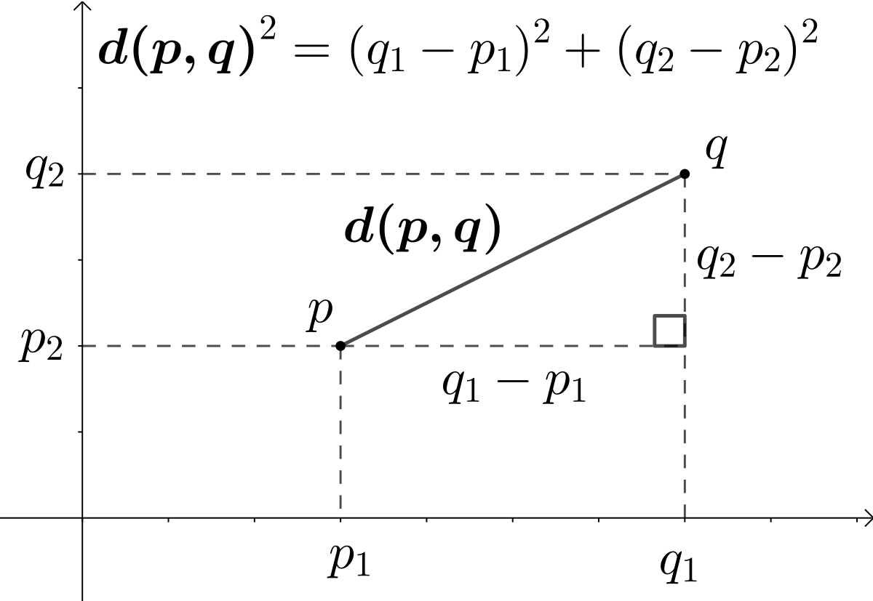

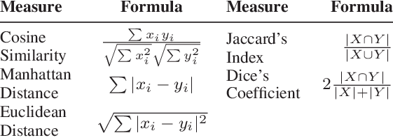

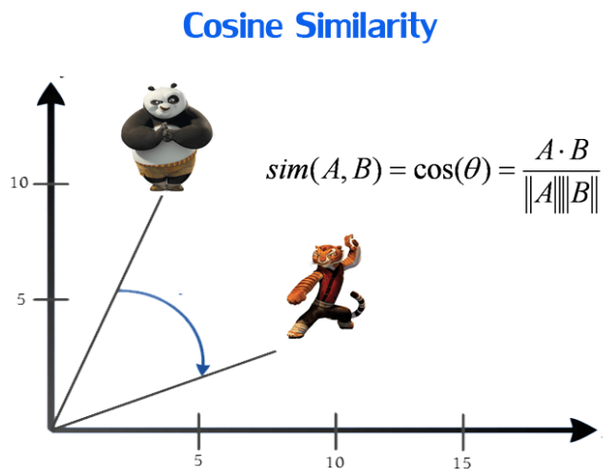

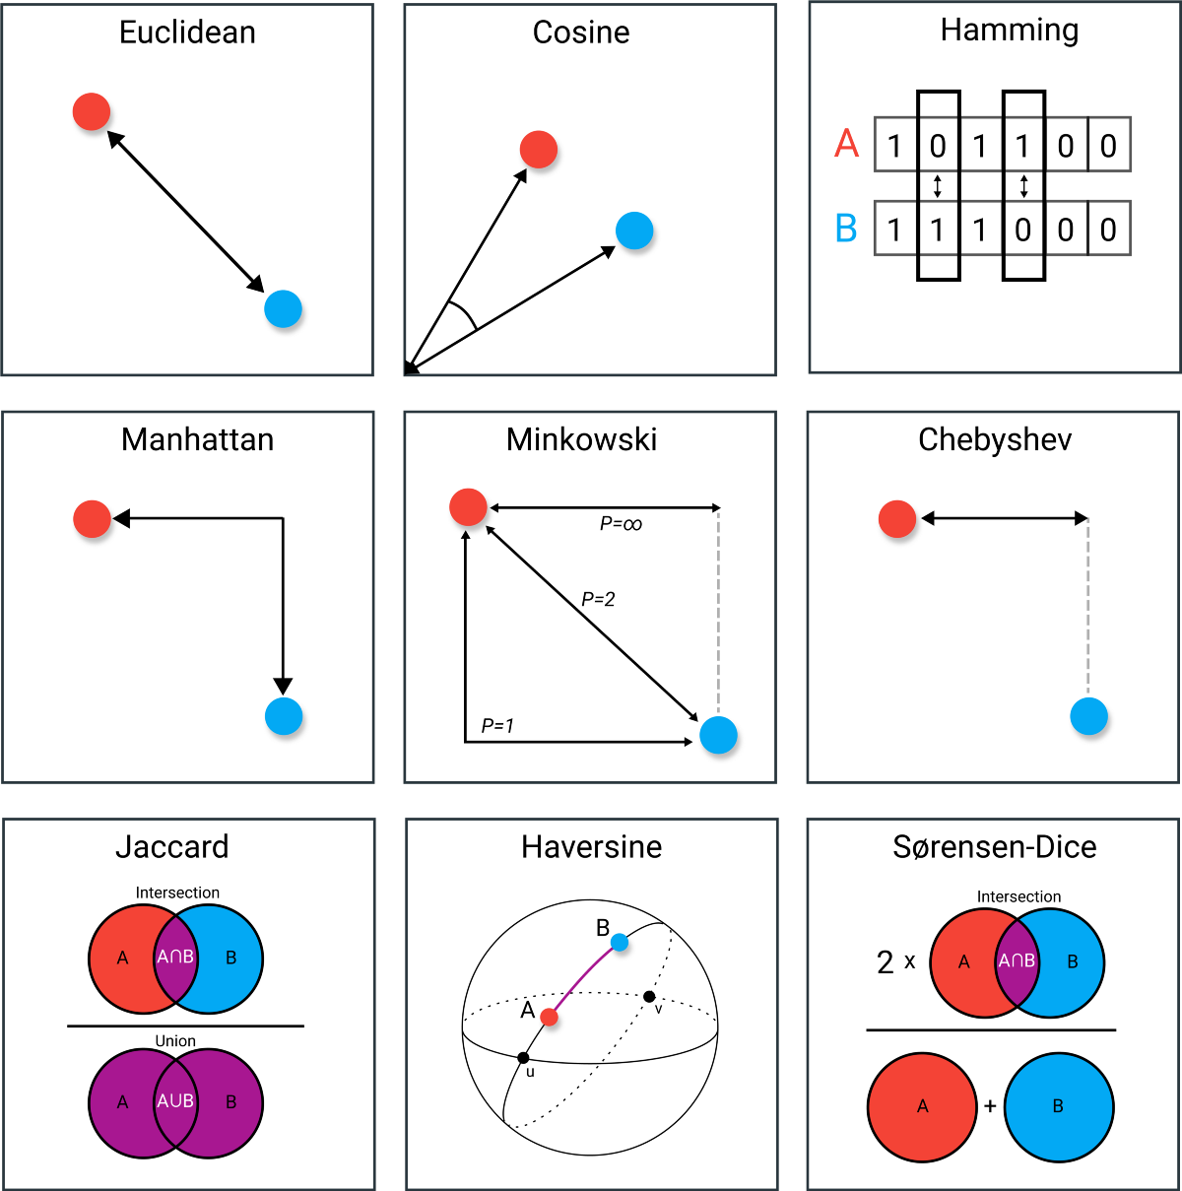

**Find the Optimal value of K using Elbow method:**

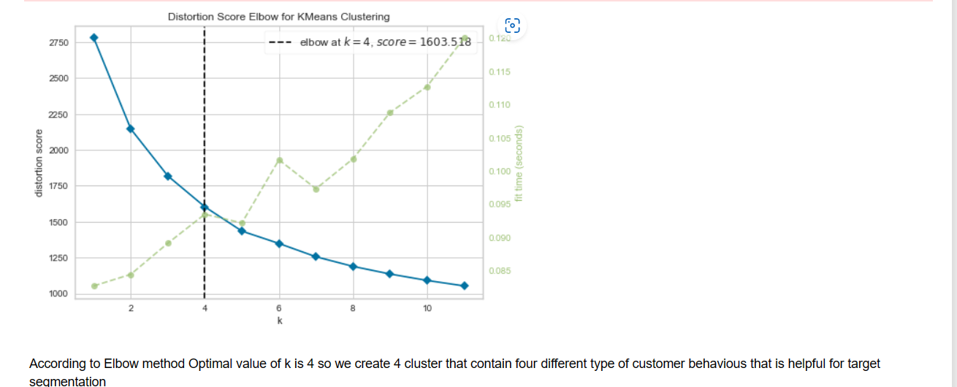

# **Hierarchical Methods:**

Hierarchical clustering refers to an unsupervised learning procedure that determines successive clusters based on previously defined clusters. It works via grouping data into a tree of clusters. Hierarchical clustering stats by treating each data points as an individual cluster. The endpoint refers to a different set of clusters, where each cluster is different from the other cluster, and the objects within each cluster are the same as one another.

There are two types of hierarchical clustering

* Agglomerative Hierarchical Clustering
* Divisive Clustering

### **Agglomerative hierarchical clustering:**

1. Determine the similarity between individuals and all other clusters. (Find proximity matrix).
2. Consider each data point as an individual cluster.
3. Combine similar clusters.
4. Recalculate the proximity matrix for each cluster.
5. Repeat step 3 and step 4 until you get a single cluster.

Let’s understand this concept with the help of graphical representation using a dendrogram.

With the help of given demonstration, we can understand that how the actual algorithm work. Here no calculation has been done below all the proximity among the clusters are assumed.Let's suppose we have six different data points P, Q, R, S, T, V.

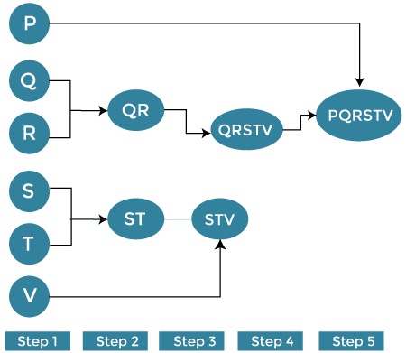

### **Divisive Hierarchical Clustering :**

Divisive hierarchical clustering is exactly the opposite of Agglomerative Hierarchical clustering. In Divisive Hierarchical clustering, all the data points are considered an individual cluster, and in every iteration, the data points that are not similar are separated from the cluster. The separated data points are treated as an individual cluster. Finally, we are left with N clusters.

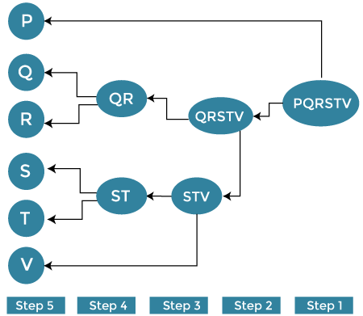

**Dendrogram Visualization:  
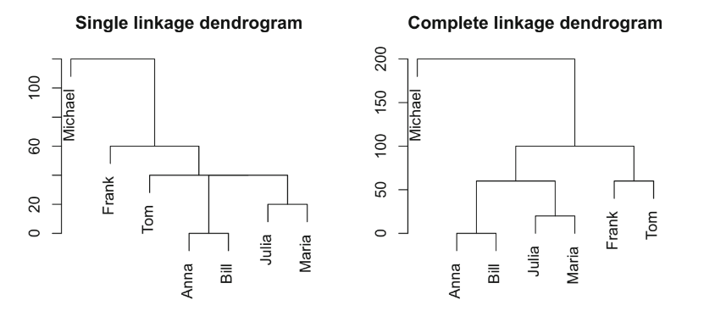**

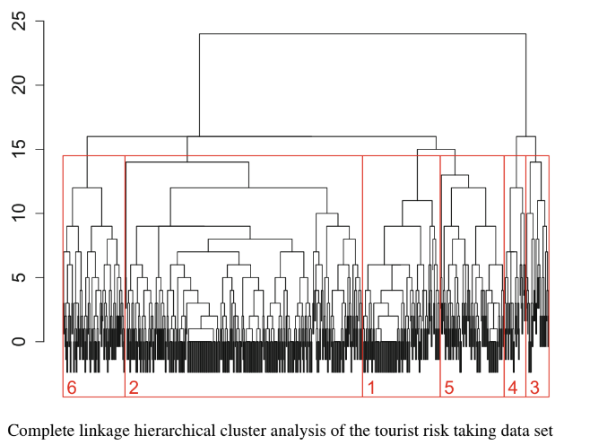

**Model Based Clustering :**

Model-based clustering is a statistical approach to data clustering. The observed (multivariate) data is considered to have been created from a finite combination of component models. Each component model is a probability distribution, generally a parametric multivariate distribution.

For instance, in a multivariate Gaussian mixture model, each component is a multivariate Gaussian distribution. The component responsible for generating a particular observation determines the cluster to which the observation belongs.

Model-based clustering is a try to advance the fit between the given data and some mathematical model and is based on the assumption that data are created by a combination of a basic probability distribution.

There are the following types of model-based clustering are as follows –

**Statistical approach** − Expectation maximization is a popular iterative refinement algorithm. An extension to k-means

* It can assign each object to a cluster according to weight (probability distribution).
* New means are computed based on weight measures.

The basic idea is as follows −

* It can start with an initial estimate of the parameter vector.
* It can be used to iteratively rescore the designs against the mixture density made by the parameter vector.
* It is used to rescored patterns are used to update the parameter estimates.
* It can be used to pattern belonging to the same cluster if they are placed by their scores in a particular component.

**Machine learning approach** − Machine learning is an approach that makes complex algorithms for huge data processing and supports results to its users. It uses complex programs that can understand through experience and create predictions.

The algorithms are improved by themselves by frequent input of training information. The main objective of machine learning is to learn data and build models from data that can be understood and used by humans.

It is a famous approach of incremental conceptual learning, which produces a hierarchical clustering in the form of a classification tree. Each node defines a concept and includes a probabilistic representation of that concept.

**Limitations**

* The assumption that the attributes are independent of each other is often too strong because correlation can exist.
* It is not suitable for clustering large database data, skewed trees, and expensive probability distributions.

**Neural Network Approach** − The neural network approach represents each cluster as an example, acting as a prototype of the cluster. The new objects are distributed to the cluster whose example is the most similar according to some distance measure.

**k-Means and k-Centroid Clustering:**

The K-means clustering algorithm is another bread-and-butter algorithm in high-dimensional data analysis that dates back many decades now (for a comprehensive examination of clustering algorithms, including the K-means algorithm, a classic text is John Hartigan’s book Clustering Algorithms).

The K-means approach, like many clustering methods, is highly algorithmic (can’t be summarized in a formula) and is iterative. The basic idea is that you are trying to find the centroids of a fixed number of clusters of points in a high-dimensional space. In two dimensions, you can imagine that there are a bunch of clouds of points on the plane and you want to figure out where the centers of each one of those clouds is.

Of course, in two dimensions, you could probably just look at the data and figure out with a high degree of accuracy where the cluster centroids are. But what if the data are in a 100-dimensional space? That’s where we need an algorithm.

The K-means approach is a partitioning approach, whereby the data are partitioned into groups at each iteration of the algorithm. One requirement is that you must**pre-specify how many clusters there are.** Of course, this may not be known in advance, but you can guess and just run the algorithm anyway. Afterwards, you can change the number of clusters and run the algorithm again to see if anything changes.

The outline of the algorithm is

1. Fix the number of clusters at some integer greater than or equal to 2
2. Start with the “centroids” of each cluster; initially you might just pick a random set of points as the centroids
3. Assign points to their closest centroid; cluster membership corresponds to the centroid assignment
4. Recalculate centroid positions and repeat.

This approach, like most clustering methods requires a defined distance metric, a fixed number of clusters, and an initial guess as to the cluster centriods. There’s no set approach to determining the initial configuration of centroids, but many algorithms simply randomly select data points from your dataset as the initial centroids.

The K-means algorithm produces

* A final estimate of cluster centroids (i.e. their coordinates)
* An assignment of each point to their respective cluster

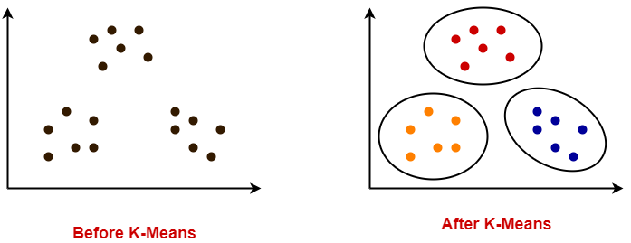

**Step 8 Selecting the Target Segments**

**The Targeting Decision**

Market segmentation is a strategic marketing tool. The selection of one or more target segments is a long-term decision significantly affecting the future performance of an organisation. This is when the flirting and dating is over; it’s time to buy a ring, pop the question, and commit.

Answering the following two questions forms the basis of target segment decision:

1. Which of the market segments would the organisation most like to target? Which segment would the organisation like to commit to?

2. Which of the organisations offering the same product would each of the segments most like to buy from? How likely is it that our organisation would be chosen? How likely is it that each segment would commit to us?

**Market Segment Evaluation**

Most books that discuss target market selection (e.g., McDonald and Dunbar 1995; Lilien and Rangaswamy 2003), recommend the use of a decision matrix to visualise relative segment attractiveness and relative organisational competitiveness for each market segment.

The aim of all these decision matrices along with their visualisations is to make it easier for the organisation to evaluate alternative market segments, and select one or a small number for targeting. It is up to the market segmentation team to decide which variation of the decision matrix offers the most useful framework to assist with decision making.

Whichever variation is chosen, the two criteria plotted along the axes cover two dimensions: segment attractiveness, and relative organisational competitiveness specific to each of the segments.

Using the analogy of finding a partner for life:

segment attractiveness is like the question Would you like to marry this person? given all the other people in the world you could marry.

Relative organisational competitiveness is like the question Would this person marry you? given all the other people in the world they could marry.

To keep segment evaluation as intuitive as possible, we label the two axes How attractive is the segment to us? and How attractive are we to the segment? We plot segment attractiveness along the x-axis, and relative organisational competitiveness along the y-axis. Segments appear as circles. The size of the circles reflects another criterion of choice that is relevant to segment selection, such as contribution to turnover or loyalty.

There is no single best measure of segment attractiveness or relative organisational competitiveness. It is therefore necessary for users to return to their specifications of what an ideal target segment looks like for them. The ideal target segment was specified in Step 2 of the market segmentation analysis. Step 2 resulted in a number of criteria of segment attractiveness, and weights quantifying how much impact each of these criteria has on the total value of segment attractiveness. To determine the attractiveness value to be used in the segment evaluation plot for each segment, the segmentation team needs to assign a value for each attractiveness criterion to each segment.

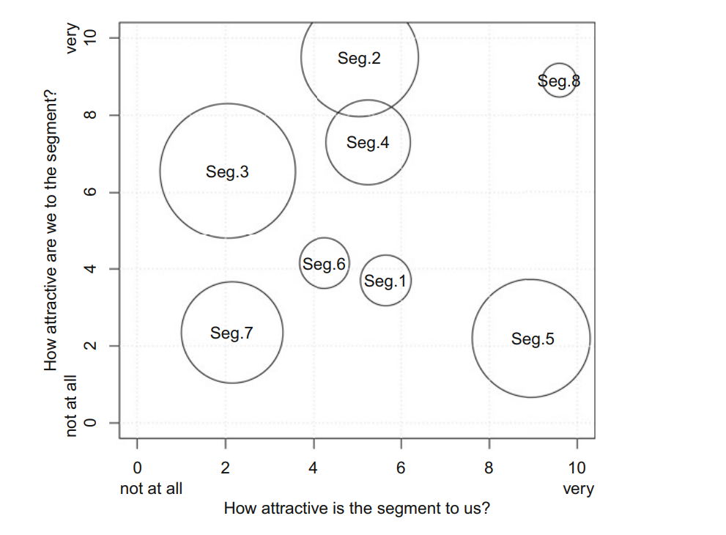

The segmentation team may eliminate from further consideration segments 3 and 7 because they are rather unattractive compared to the other available segments despite the fact that they have high profit potential (as indicated by the size of the bubbles). Segment 5 is obviously highly attractive and has high profit potential, but unfortunately the segment is not as fond of the organisation as the organisation is of the segment. It is unlikely, at this point in time, that the organisation will be able to cater successfully to segment 5. Segment 8 is excellent because it is highly attractive to the organisation, and views the organisation’s offer as highly attractive. A match made in heaven, except for the fact that the profit potential is not very high. It may be necessary, therefore to consider including segment 2. Segment 2 loves the organisation, has decent profit potential, and is about equally attractive to the organisation as segments 1, 4 and 6 (all of which, unfortunately, are not very fond of the organisation’s offer).

**Step 4 Exploring Data**

After data collection, exploratory data analysis cleans and pre-processes the data. This exploration stage also offers guidance on the most suitable algorithm for extracting meaningful market segments.

Data exploration helps in following things

(1) identify the measurement levels of the variables

(2) investigate the univariate distributions of each of the variables

(3) assess dependency structures between variables.

To illustrate data exploration using real data, we use a travel motives data set. This data set contains 20 travel motives reported by 1000 Australian residents in relation to their last vacation. The dataset can be downloaded from following link.

The link for dataset: <http://www.marketsegmentationanalysis.org/>

To read dataset using Python we use following code:-

import pandas as pd

vacation=pd.read_csv('Book1.csv') //Book1.csv is our travel motive dataset

vacation.head()

After executing above commands, it gives first 5 rows from the dataset.

We can inspect the dataset, and learn about column names, and the size of the data set using the commands:

vacation.info()

It will give following output:

# Column Non-Null Count Dtype

--- ------ -------------- -----

0 Gender 1000 non-null object

1 Age 1000 non-null float64

2 Education 992 non-null float64

3 Income 934 non-null object

4 Income2 934 non-null object

5 Occupation 941 non-null object

6 State 1000 non-null object

7 Relationship.Status 996 non-null object

8 Obligation 1000 non-null float64

9 Obligation2 1000 non-null object

10 NEP 1000 non-null float64

11 Vacation.Behaviour 975 non-null float64

12 rest and relax 1000 non-null object

13 luxury / be spoilt 1000 non-null object

14 do sports 1000 non-null object

15 excitement, a challenge 1000 non-null object

16 not exceed planned budget 1000 non-null object

17 realise creativity 1000 non-null object

18 fun and entertainment 1000 non-null object

19 good company 1000 non-null object

20 health and beauty 1000 non-null object

21 free-and-easy-going 1000 non-null object

22 entertainment facilities 1000 non-null object

23 not care about prices 1000 non-null object

24 life style of the local people 1000 non-null object

25 intense experience of nature 1000 non-null object

26 cosiness/familiar atmosphere 1000 non-null object

27 maintain unspoilt surroundings 1000 non-null object

28 everything organised 1000 non-null object

29 unspoilt nature/natural landscape 1000 non-null object

30 cultural offers 1000 non-null object

31 change of surroundings 1000 non-null object

Here we see that there are 32 columns and their data types.

we can select four columns to show Gender (column 1 of the data set), Age (column 2), Income (column 4), and Income2 (column 5) using following code in Python.

vacation1 = pd.DataFrame(vacation, columns=['Gender', 'Age', 'Income', 'Income2'])

vacation1

The output of the above command give rows corresponding to Gender, Age , Income And Income2.

We can count the number of men and women in the dataset as

vacation1['Gender'].value_counts()

It will give output as

Male 512

Female 488

Name: Gender, dtype: int64

We can also view the insights of column Age by writing following command in Python

vacation1['Age'].describe()

count 1000.000000

mean 44.168000

std 14.539228

min 18.000000

25% 32.000000

50% 42.000000

75% 57.000000

max 105.000000

Name: Age, dtype: float64

The age of the respondents is a metric variable summarised by the count, the mean, the standard deviation(std), the minimum value(min), the first quartile(25%), the second quartile(50%), the third quartile (75%), and the maximum value (max). The youngest respondent is 18, and the oldest 105 years old. The mean age of all travellers is 44.16.

The ‘vacation1’ contains two more columns namely Income and Income2.The insights into these columns can be seen by following python code.

Code: vacation1['Income'].value_counts()

Output:

$30,001 to $60,000 265

$60,001 to $90,000 233

Less than $30,000 150

$90,001 to $120,000 146

$120,001 to $150,000 72

$150,001 to $180,000 32

$180,001 to $210,000 15

more than $240,001 11

$210,001 to $240,000 10

Name: Income, dtype: int64

Code: vacation1['Income2'].value_counts()

Output:

30-60k 265

60-90k 233

<30k 150

90-120k 146

>120k 140

Name: Income2, dtype: int64

**Data cleaning**

The first step before commencing data analysis is to clean the data. This includes checking if all values have been recorded correctly, and if consistent labels for the levels of categorical variables have been used. For many metric variables, the range of plausible values is known in advance. For example, age (in years) can be expected to lie between 0 and 110. It is easy to check whether any implausible values are contained in the data, which might point to errors during data collection or data entry.

Similarly, levels of categorical variables can be checked to ensure they contain only permissible values. For example, gender typically has two values in surveys: female and male. Unless the questionnaire did offer a third option, only those two should appear in the data. Any other values are not permissible, and need to be corrected as part of the data cleaning procedure.

Returning to the Australian travel motives data set, the summary for the variables Gender and Age indicates that no data cleaning is required for these variables.

**Descriptive Analysis**

Being familiar with the data avoids misinterpretation of results from complex analyses. Descriptive numeric and graphic representations provide insights into data. Helpful graphical methods for numeric data are histograms, boxplots and scatter plots. Bar plots of frequency counts are useful for the visualisation of categorical variables.

Histograms visualise the distribution of numeric variables. They show how often observations within a certain value range occur. Histograms reveal if the distribution of a variable is unimodal and symmetric or skewed. To obtain a histogram, we first need to create categories of values. We call this binning. The bins must cover the entire range of observations, and must be adjacent to one another. Usually, they are of equal length. Once we have created the bins, we plot how many of the observations fall into each bin using one bar for each bin. We plot the bin range on the x-axis, and the frequency of observations in each bin on the y-axis.

Code:

Import matplotlib.pyplot as plt

plt.hist(vacation1['Age'],bins=10,histtype='barstacked',color='red')

plt.xlabel('Age')

plt.ylabel('No of tourists')

plt.title('Age vs No of tourists')

plt.show()

Output:

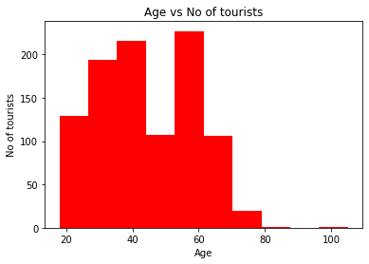

We can avoid selecting bin widths by using the box-and-whisker plot or boxplot. The boxplot is the most common graphical visualisation of unimodal distributions in statistics. It is widely used in the natural sciences, but does not enjoy the same popularity in business, and the social sciences more generally. The simplest version of a boxplot compresses a data set into minimum, first quartile, median, third quartile and maximum.

We first analyse Column Age:

vacation1['Age'].describe()

count 1000.000000

mean 44.168000

std 14.539228

min 18.000000

25% 32.000000

50% 42.000000

75% 57.000000

max 105.000000

Code:

import seaborn as sns

sns.boxplot(vacation1['Age'])

Output:

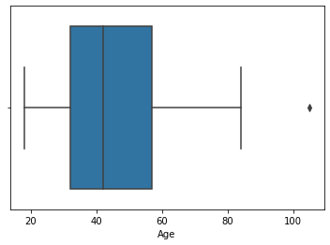

**Pre-processing**

**1.categorical variable**

Two pre-processing procedures are often used for categorical variables. One is merging levels of categorical variables before further analysis, the other one is converting categorical variables to numeric ones, if it makes sense to do so.

**2. Numerical variable**

The range of values of a segmentation variable affects its relative influence in distance-based methods of segment extraction. If, for example, one of the segmentation variables is binary (with values 0 or 1 indicating whether or not a tourist likes to dine out during their vacation), and a second variable indicates the expenditure in dollars per person per day (and ranges from zero to $1000), a difference in spend per person per day of one dollar is weighted equally as the difference between liking to dine out or not. To balance the influence of segmentation variables on segmentation results, variables can be standardised. Standardising variables means transforming them in a way that puts them on a common scale.

**Principal Component Analysis**

1.Principal Component Analysis is a well-known dimension reduction technique.

2.It transforms the variables into a new set of variables called as principal components.

3.These principal components are linear combination of original variables and are orthogonal.

4.The first principal component accounts for most of the possible variation of original data.

5.The second principal component does its best to capture the variance in the data.

6.There can be only two principal components for a two-dimensional data set.

**Algorithm**

**Step-01:** Get Data.

**Step-02:** Compute the mean vector (µ).

**Step-03:** Subtract mean from the given data.

**Step-04:** Calculate the covariance matrix.

**Step-05:** Calculate the eigen vectors and eigen values of the covariance matrix.

**Step-06:** Choosing components and forming a feature vector.

**Step-07:** Deriving the new data set.

**Step 6: Profiling Segments**

**Identifying Key Characteristics of Market Segments**

The aim of the profiling step is to get to know the market segments resulting from the extraction step. Profiling is only required when data-driven market segmentation is used. For commonsense segmentation, the profiles of the segments are predefined. If, for example, age is used as the segmentation variable for the commonsense segmentation, it is obvious that the resulting segments will be age groups. Therefore, this step is not necessary when commonsense segmentation is conducted.

The situation is quite different in the case of data-driven segmentation: users of the segmentation solution may have decided to extract segments on the basis of benefits sought by consumers.

Yet – until after the data has been analysed – the defining characteristics of the resulting market segments are unknown. Identifying these defining characteristics of market segments with respect to the segmentation variables is the aim of profiling. Profiling consists of characterising the market segments individually, but also in comparison to the other market segments.

At the profiling stage, we inspect a number of alternative market segmentation solutions. This is particularly important if no natural segments exist in the data, and either a reproducible or a constructive market segmentation approach has to be taken. Good profiling is the basis for correct interpretation of the resulting segments. Correct interpretation, in turn, is critical to making good strategic marketing decisions.

**Traditional Approaches to Profiling Market Segments**

Data-driven segmentation solutions are usually presented to users (clients, managers) in one of two ways:

(1) as high level summaries simplifying segment characteristics to a point where they are misleadingly trivial, or

(2) as large tables that provide, for each segment, exact percentages for each segmentation variable.

Such tables are hard to interpret, and it is virtually impossible to get a quick overview of the key insights.

**Segment Profiling with Visualisations**

Neither the highly simplified, nor the very complex tabular representation typically used to present market segmentation solutions make much use of graphics, although data visualisation using graphics is an integral part of statistical data analysis. Graphics are particularly important in exploratory statistical analysis (like cluster analysis) because they provide insights into the complex relationships between variables. In addition, in times of big and increasingly bigger data, visualisation offers a simple way of monitoring developments over time.

* **Identifying Defining Characteristics of Market Segments**

A good way to understand the defining characteristics of each segment is to produce a segment profile plot. The segment profile plot shows – for all segmentation variables - how each market segment differs from the overall sample. The segment profile plot is the direct visual translation of tables.

In figures and tables, segmentation variables do not have to be displayed in the order of appearance in the data set. If variables have a meaningful order in the data set, the order should be retained. If, however, the order of variables is independent of content, it is useful to rearrange variables to improve visualisations.

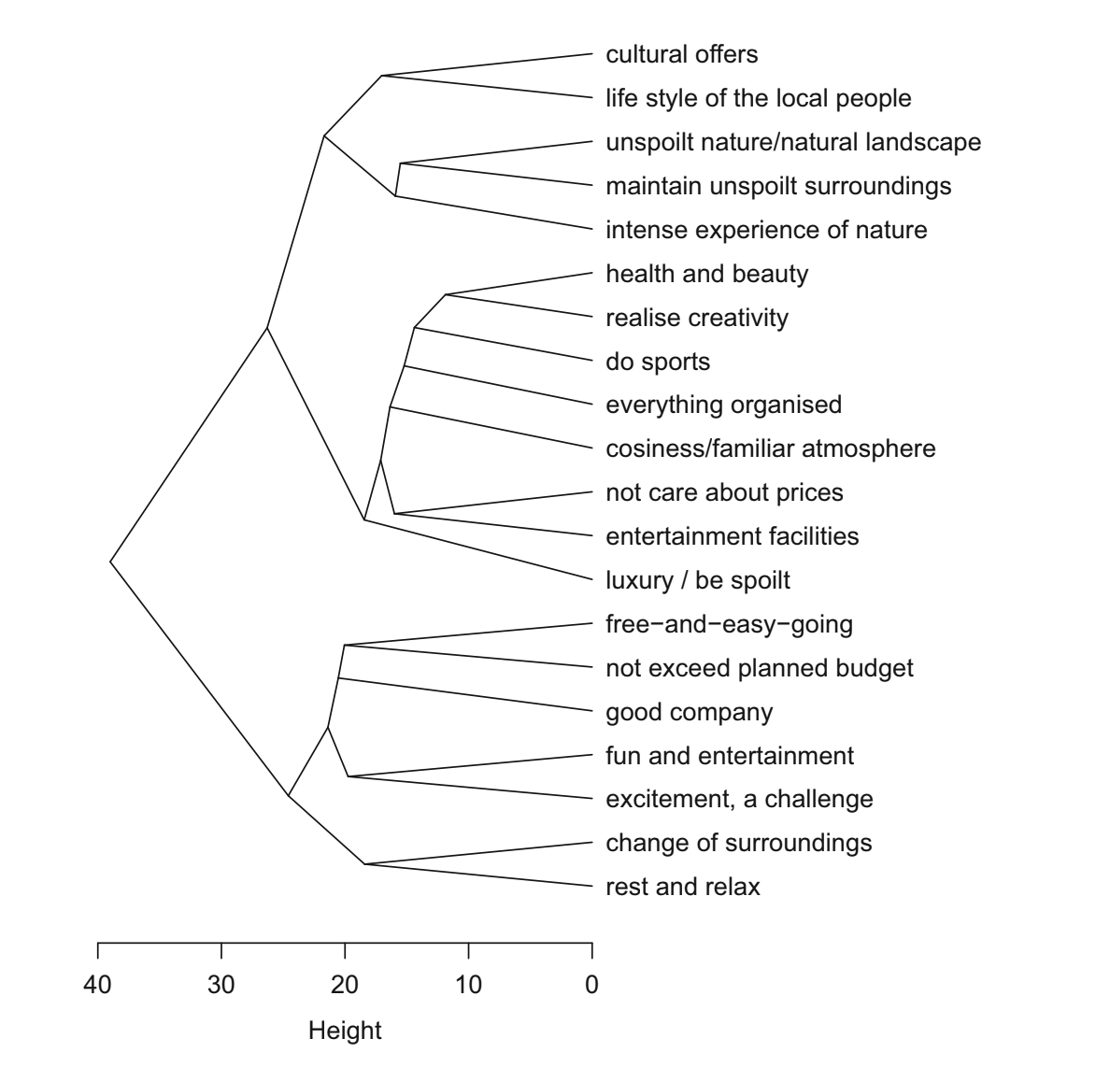

* **Assessing Segment Separation**

Segment separation can be visualised in a segment separation plot. The segment separation plot depicts – for all relevant dimensions of the data space – the overlap of segments.

Segment separation plots are very simple if the number of segmentation variables is low, but become complex as the number of segmentation variables increases. But even in such complex situations, segment separation plots offer data analysts and users a quick overview of the data situation, and the segmentation solution.

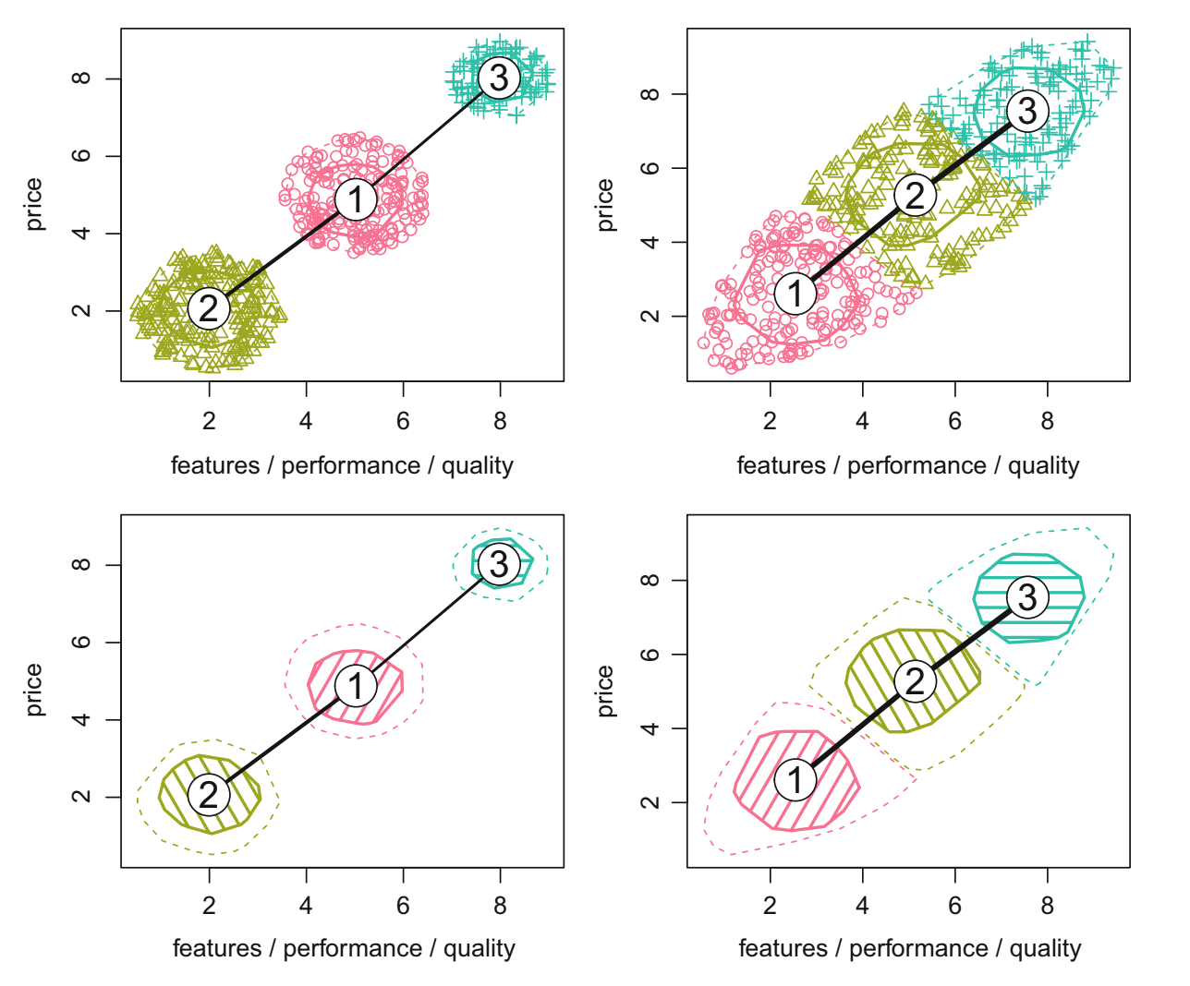

**Step 9: Customising the Marketing Mix**

**Implications for Marketing Mix Decisions**

Marketing was originally seen as a toolbox to assist in selling products, with marketers mixing the ingredients of the toolbox to achieve the best possible sales results. In the early days of marketing, Borden (1964) postulated that marketers have at their disposal 12 ingredients: product planning, packaging, physical handling, distribution channels, pricing, personal selling, branding, display, advertising, promotions, servicing, fact finding and analysis. Many versions of this marketing mix have since been proposed, but most commonly the marketing mix is understood as consisting of the 4Ps: Product, Price, Promotion and Place.

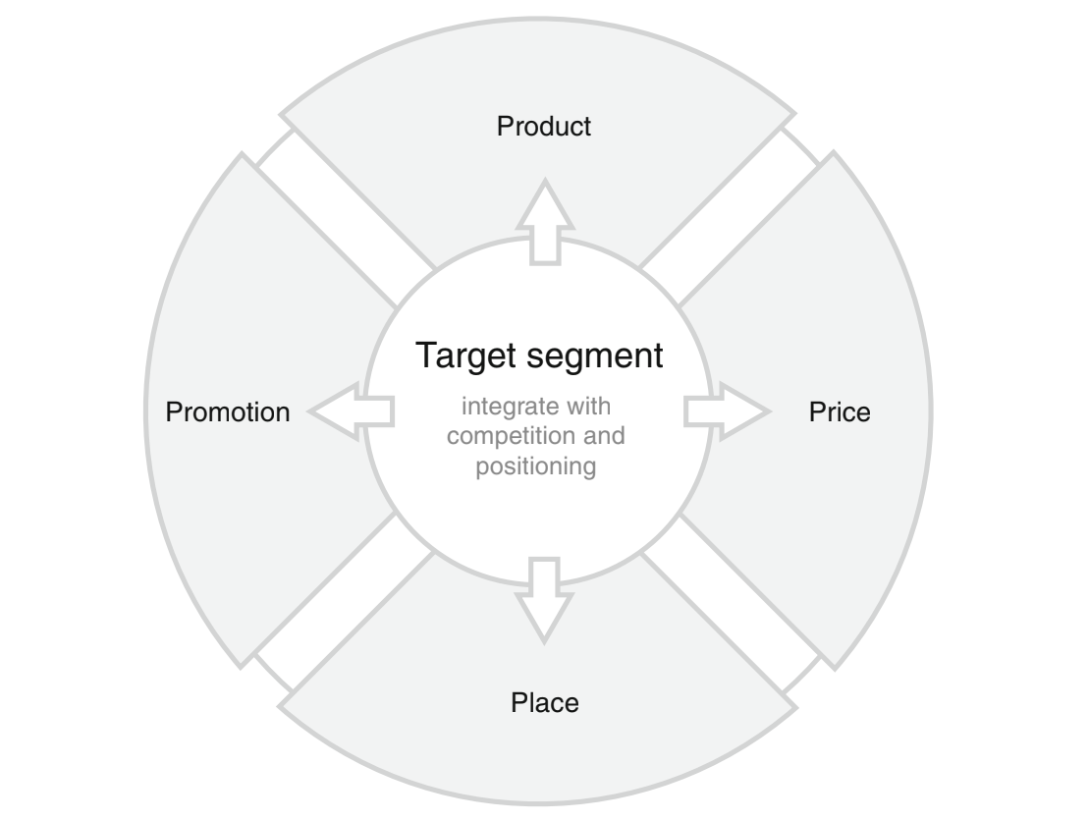

**Product**

One of the key decisions an organisation needs to make when developing the product dimension of the marketing mix, is to specify the product in view of customer needs. Often this does not imply designing an entirely new product, but rather modifying an existing one. Other marketing mix decisions that fall under the product dimension are: naming the product, packaging it, offering or not offering warranties, and after sales support services.

**Price**

Typical decisions an organisation needs to make when developing the price dimension of the marketing mix include setting the price for a product, and deciding on discounts to be offered.

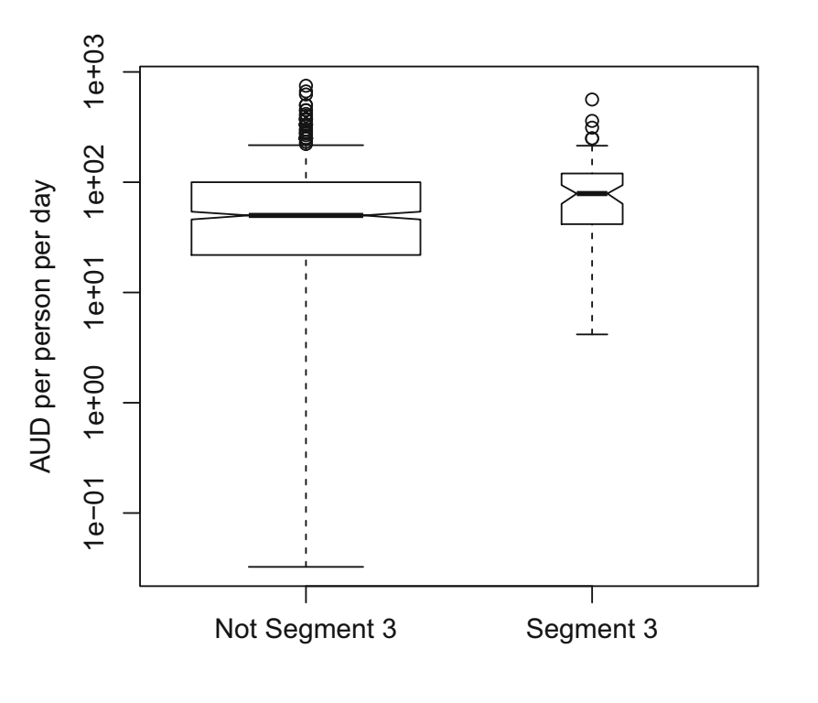

**Place**

The key decision relating to the place dimension of the marketing mix is how to distribute the product to the customers. This includes answering questions such as:

* should the product be made available for purchase online or offline only or both;
* should the manufacturer sell directly to customers; or should a wholesaler or a retailer or both be used.

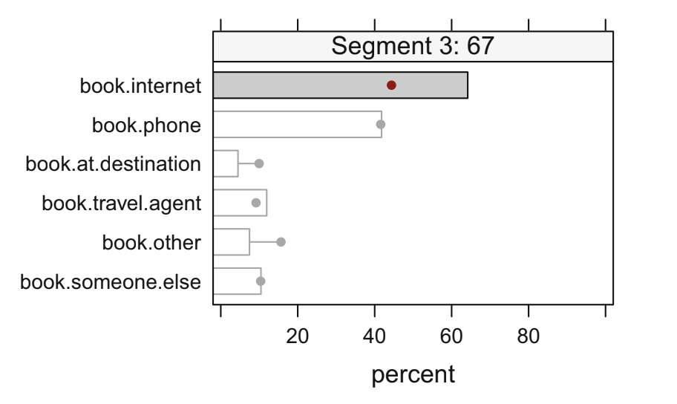

**Promotion**

Typical promotion decisions that need to be made when designing a marketing mix include: developing an advertising message that will resonate with the target market, and identifying the most effective way of communicating this message. Other tools in the promotion category of the marketing mix include public relations, personal selling, and sponsorship.

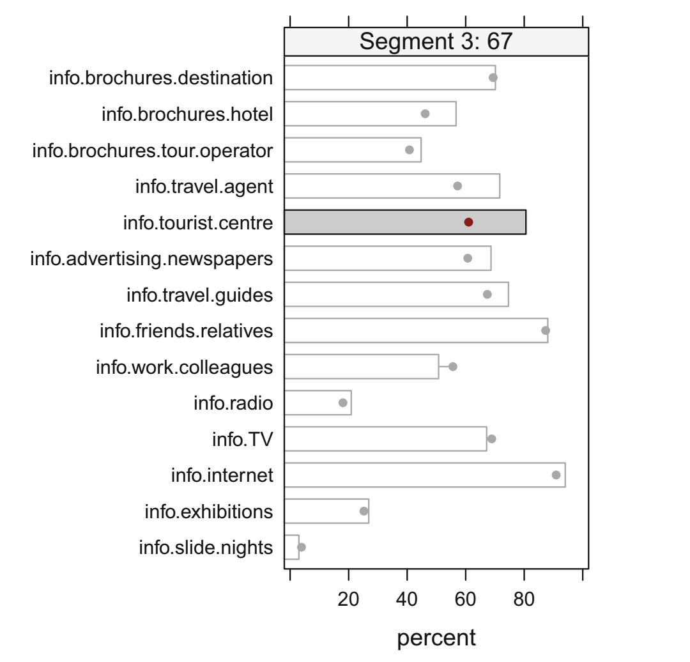

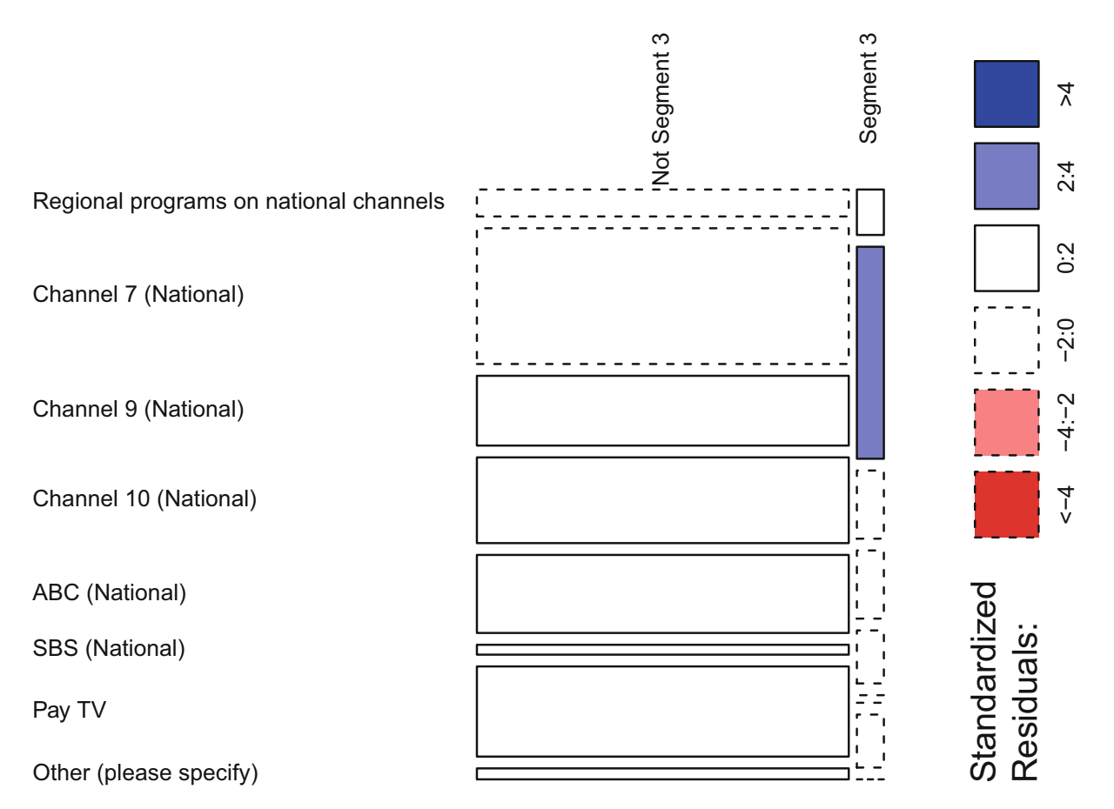

**Step 10 :**

**Code Analysis**

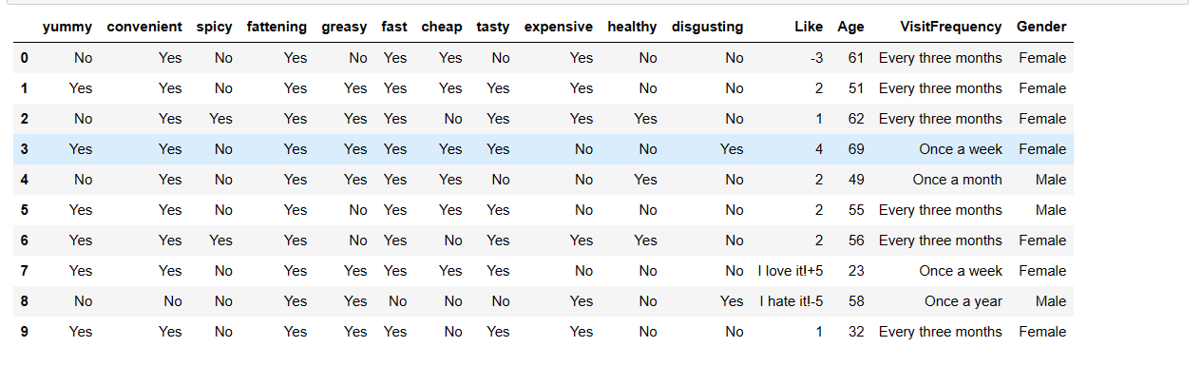

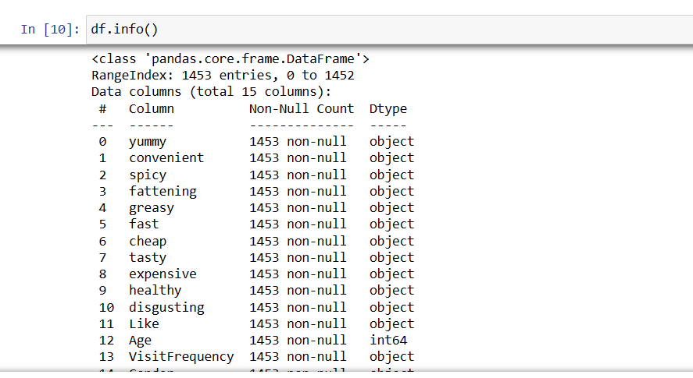

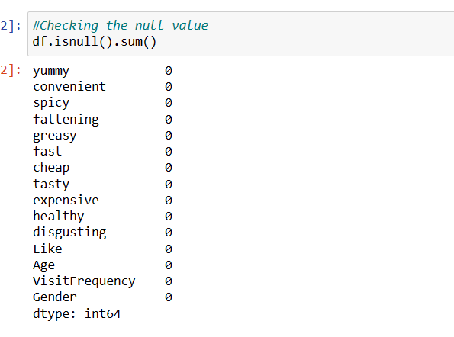

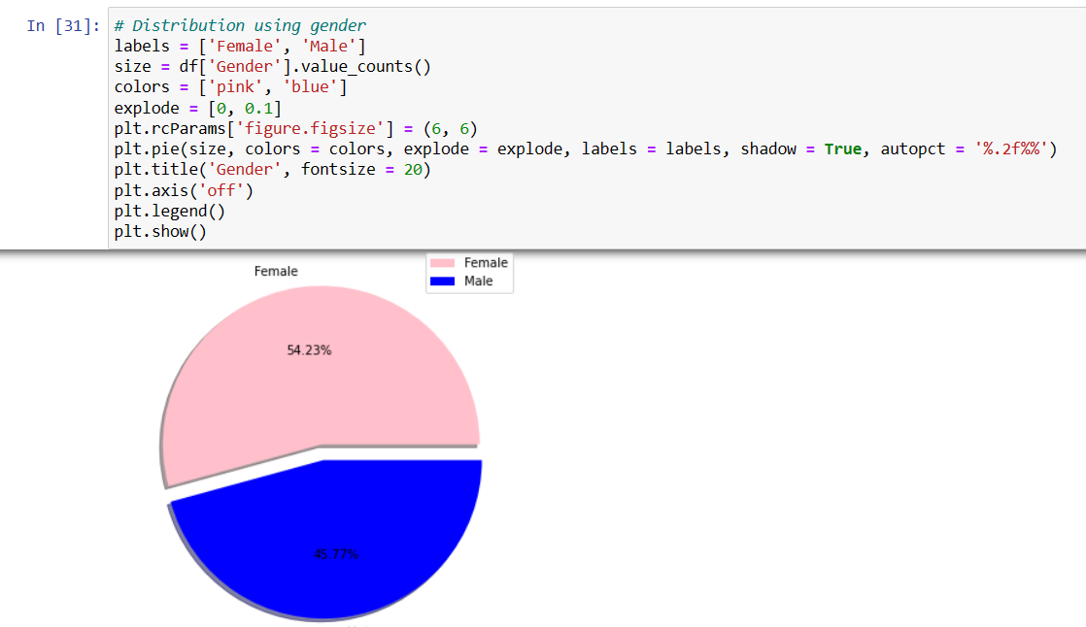

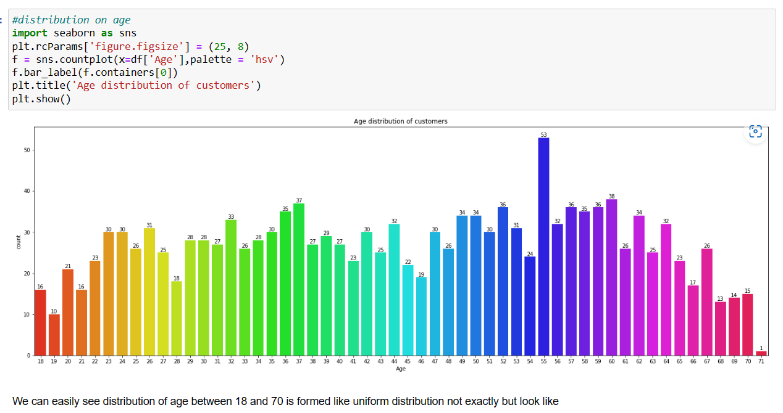

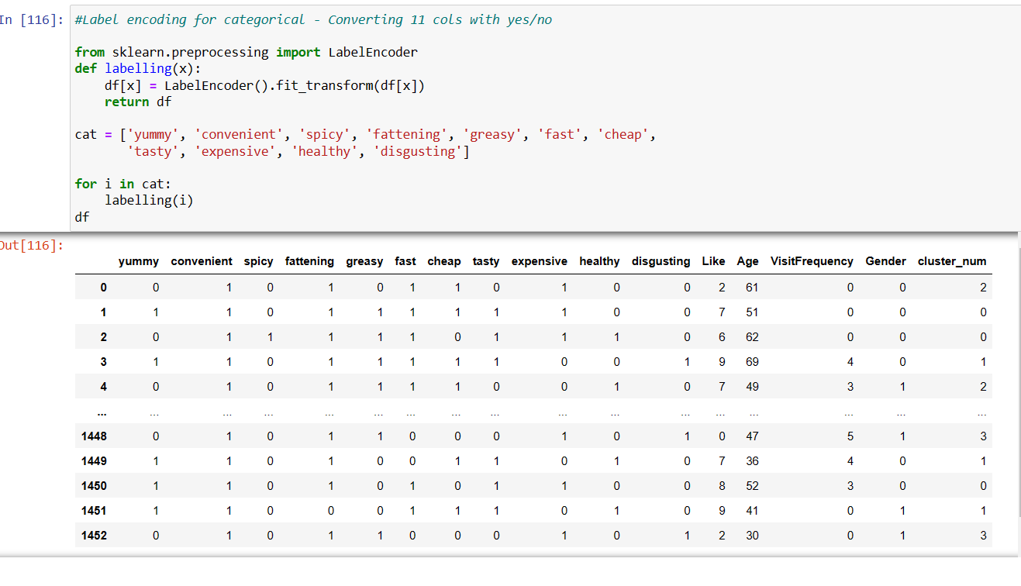

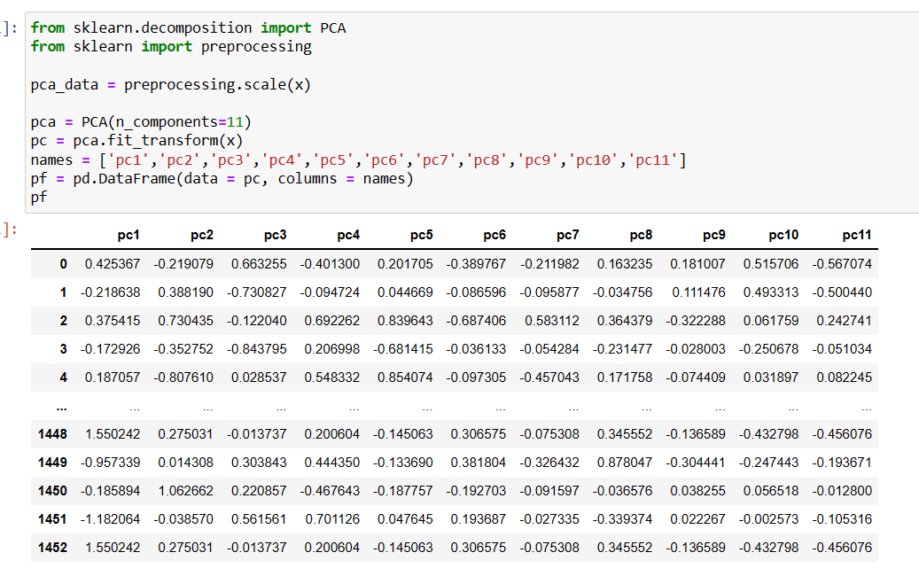

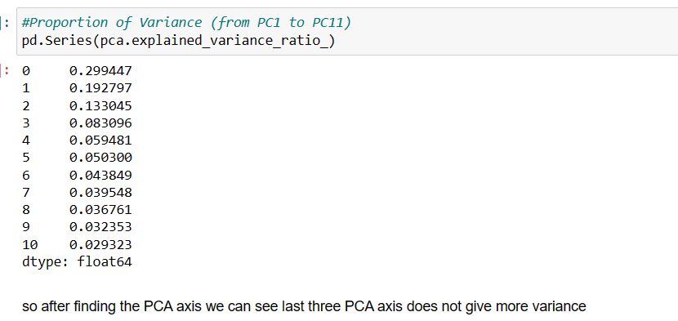



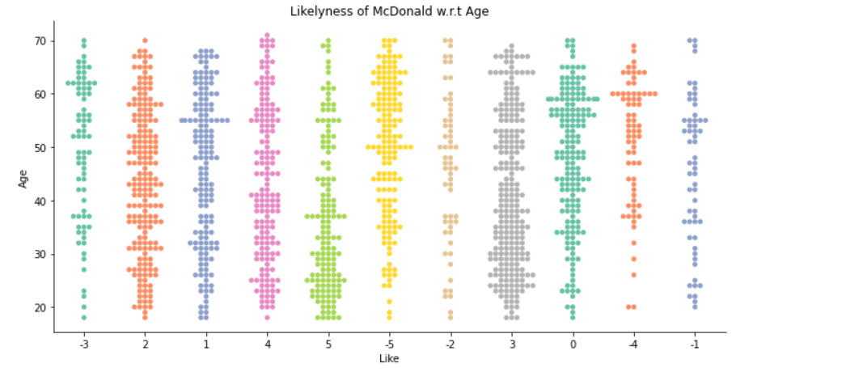

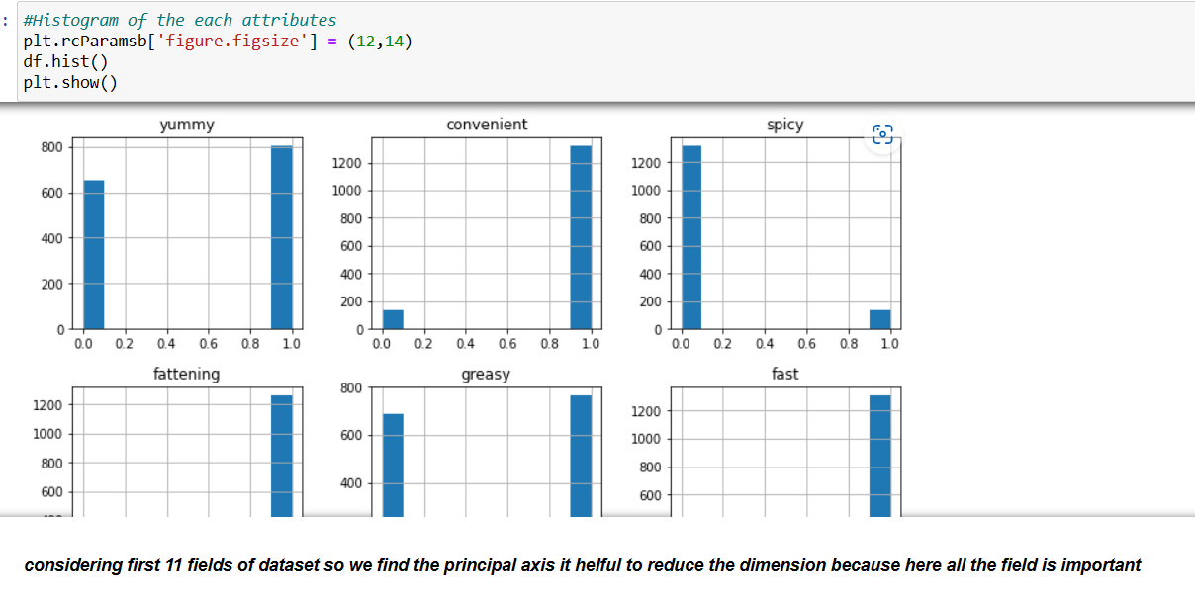

**Refrences :**

[https://ai-pool.com/a/s/finding-an-optimal-number-of-clusters-with-elbow-method https://www.youtube.com/watch?v=1XqG0kaJVHY](https://ai-pool.com/a/s/finding-an-optimal-number-of-clusters-with-elbow-method%20https:/www.youtube.com/watch?v=1XqG0kaJVHY)

<https://www.javatpoint.com/k-means-clustering-algorithm-in-machine-learning>

<https://rpubs.com/tmk1221/segmentation>

<https://medium.com/analytics-vidhya/mathematics-behind-principal-component-analysis-pca-1cdff0a808a9#:~:text=PCA%20uses%20the%20concepts%20of%20linear%20algebraand%20optimization,and%20project%20the%20data%20points%20on%20that%20direction.>

[The Mathematics Behind Principal Component Analysis (PCA) | by Madhav Samariya | Analytics Vidhya | Medium](https://medium.com/analytics-vidhya/mathematics-behind-principal-component-analysis-pca-1cdff0a808a9#:~:text=PCA%20uses%20the%20concepts%20of%20linear%20algebraand%20optimization,and%20project%20the%20data%20points%20on%20that%20direction.)

<https://www.bing.com/search?q=market+segmentation+using+cluster+analysis&cvid=9a4c080edea84b81b7d188313d56566d&aqs=edge.0.0j69i57j0l7.10144j0j4&FORM=ANAB01&PC=HCTS>

**Github Repository code:**

* Madhur Sharma

<https://github.com/Madhursharma98/Mcdonald-Target-segmentation>

* Naveen Kumar

<https://github.com/Naveenkumar900/Macdonald-data-analysis>

* Anduri Roshan

<https://github.com/roshananduri/FeyNNLabs_StudyTask>

Animisha Gadde

<https://github.com/animisha6502/McDonalds-Market-Segmentation>